浙 江 财 经 大 学

实 验（实训）报 告

项 目 名 称 二阶段最小二乘法
所属课程名称 计量经济学（双语）
项 目 类 型 综合性实验
实验(实训)日期 2025年04月21日

班 级 22应用统计
学 号 220110780419
姓 名 刘晓亮
指导教师 倪伟才 ___

浙江财经大学教务处制
一、实验（实训）概述：
【目的及要求】
目的: 掌握二阶段最小二乘法的估计。

要求: 掌握二阶段最小二乘法的估计,按具体的题目要求完成实验报告,并及时上传到彩云系统。

【基本原理】
2SLS
【实施环境】（使用的材料、设备、软件）
STATA软件

二、实验（实训）内容：
【项目内容】
2SLS
【方案设计】
题目来自《Econometric Analysis of Cross Section and Panel Data》 J.M.Wooldridge, MIT, chapter 4 problems 5.4]

【实验（实训）过程】（步骤、记录、数据、程序等）
附后
【结论】（结果、分析）
附后
三、指导教师评语及成绩：
评语：对2sls理解深入，可以流畅分析问题

成绩： 优秀 指导教师签名：倪伟才
批阅日期：25年05月
实 验 六 报 告
二阶段最小二乘估计（综合性实验）
实验类型：综合性实验
实验目的：
掌握二阶段最小二乘法的估计。
实验内容：
二阶段最小二乘估计。
实验要求：
掌握二阶段最小二乘的估计,按具体的题目要求完成实验报告,并及时上传到给定彩云系统。

实验题目：
[abstracted from《Econometric Analysis of Cross Section and Panel Data》 J.M.Wooldridge, MIT, chapter 4 problems 5.4]
Use the data in CARD. DTA for this problem.
a. Estimate a logwage equation by OLS with educ, exper, exper², black, south,
smsa, reg661 through reg668, and smsa66 as explanatory variables.
b. Estimate a reduced form equation for educ containing all explanatory variables
from part a and the dummy variable nearc4. Do educ and nearc4 have a practically
and statistically significant partial correlation?
c. Estimate the logwage equation by IV, using nearc4 as an instrument for educ.
Compare the 95 percent confidence interval for the return to education with that
obtained from part a.
d. Now use nearc2 along with nearc4 as instruments for educ. First estimate the
reduced form for educ, and comment on whether nearc2 or nearc4 is more strongly
related to educ. How do the 2SLS estimates compare with the earlier estimates?
e. For a subset of the men in the sample, IQ score is available. Regress iq on nearc4.
Is IQ score uncorrelated with nearc4?
f. Now regress iq on nearc4 along with smsa66, reg661, reg662, and reg668. Are iq
and nearc4 partially correlated? What do you conclude about the importance of
controlling for the 1966 location and regional dummies in the logwage equation
when using nearc4 as an IV for educ?

实验题目分析报告：
a.
,lwage-=0.0746933⋅educ+0.0848332⋅exper−0.002287⋅expersq--−0.1990123⋅black−0.147955⋅south+0.1363845⋅smsa--−0.1185698⋅reg61−0.0222026⋅reg62+0.0259703⋅reg63--−0.0634942⋅reg64+0.0094551⋅reg65+0.0219476⋅reg66--−0.0005887⋅reg67−0.1750058⋅reg68+0.0262417⋅smsa66--+4.739377.
use "card.dta",clear
reg lwage educ exper expersq black south smsa reg661 reg662 reg663 reg664 reg665 reg666 reg667 reg668 smsa66
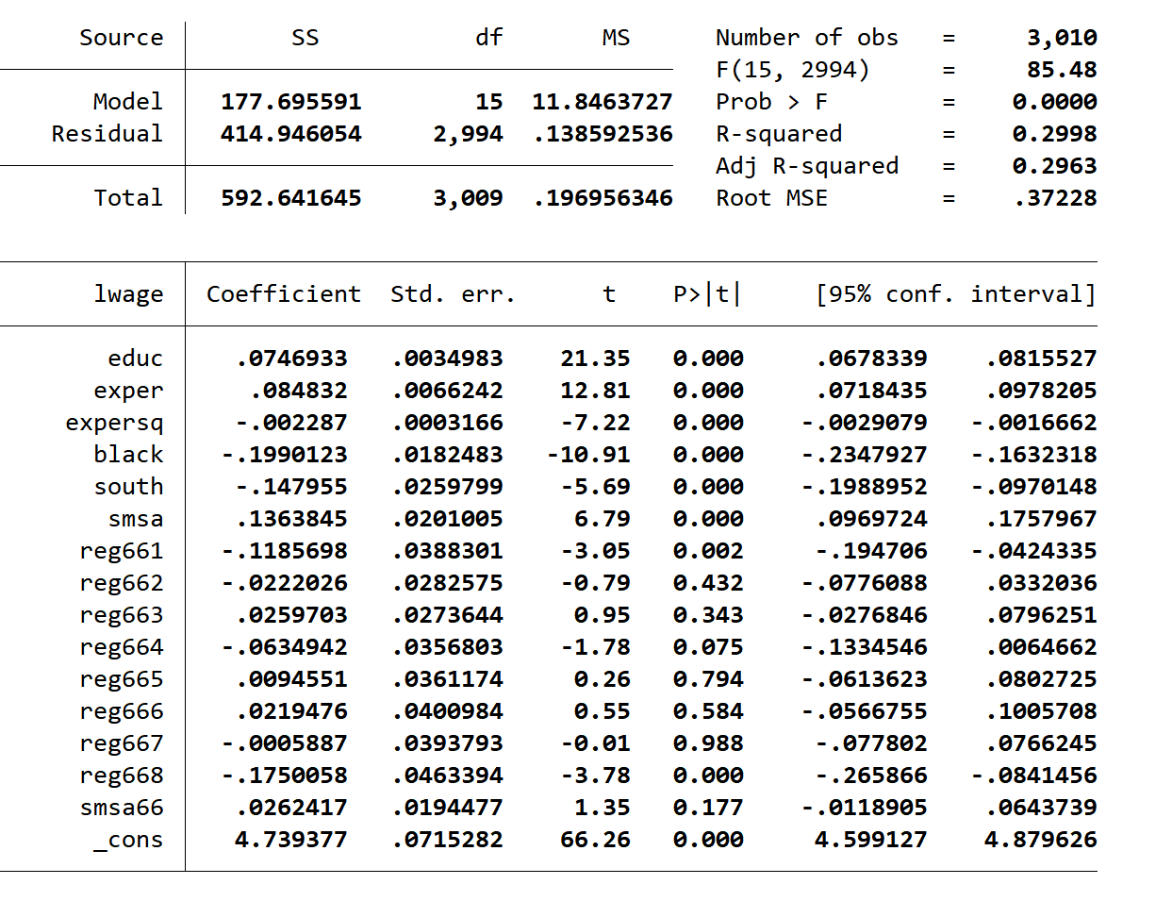
b.
reg educ nearc4 reg661 reg662 reg663 reg664 reg665 reg666 reg667 reg668 smsa66

是的，具有很强的证据表明他们之间是强相关的
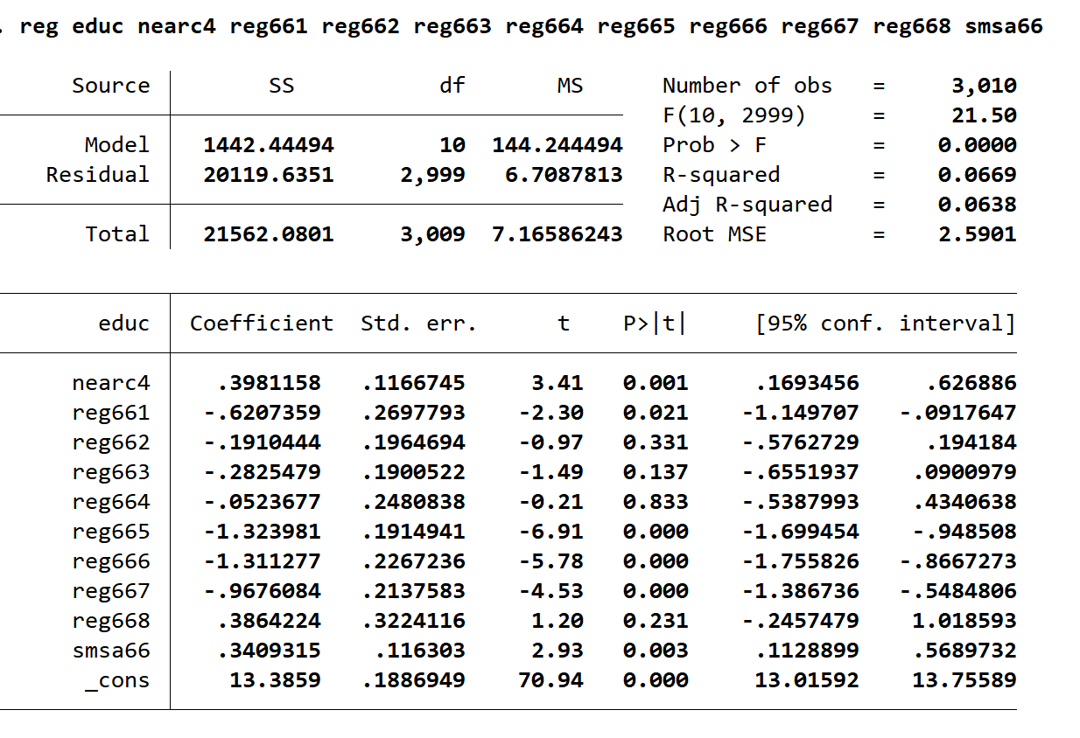
c.
ivreg lwage (educ = nearc4) exper expersq black south smsa reg661 reg662 reg663 reg664 reg665 reg666 reg667 reg668 smsa66,first

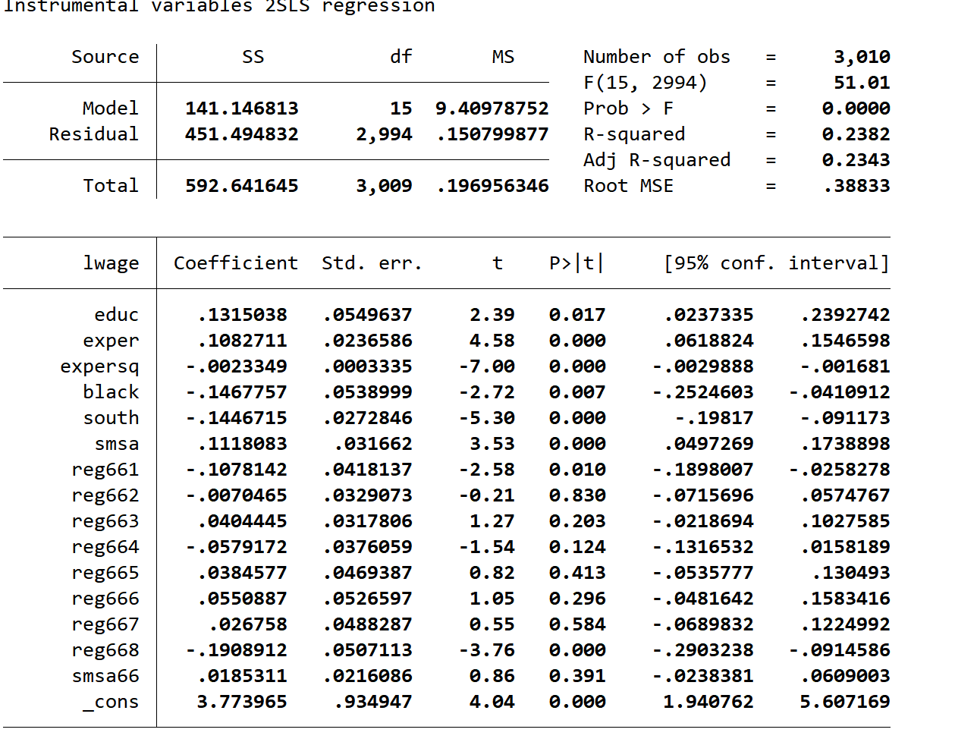
ivreg lwage (educ = nearc4 ) exper expersq black smsa south smsa66 reg662-reg669
estimates store iv
reg lwage educ exper expersq black smsa south smsa66 reg662-reg669
estimates store ols
esttab iv ols,ci(2) level(95)
 | ols | Iv
educ | 0.132* | 0.0747***
 | [0.02,0.24] | [0.07,0.08]
exper | 0.108*** | 0.0848***
 | [0.06,0.15] | [0.07,0.10]
expersq | -0.00233*** | -0.00229***
 | [-0.00,-0.00] | [-0.00,-0.00]
black | -0.147** | -0.199***
 | [-0.25,-0.04] | [-0.23,-0.16]
smsa | 0.112*** | 0.136***
 | [0.05,0.17] | [0.10,0.18]
south | -0.145*** | -0.148***
 | [-0.20,-0.09] | [-0.20,-0.10]
smsa66 | 0.0185 | 0.0262
 | [-0.02,0.06] | [-0.01,0.06]
reg662 | 0.101** | 0.0964**
 | [0.03,0.17] | [0.03,0.17]
reg663 | 0.148*** | 0.145***
 | [0.08,0.22] | [0.08,0.21]
reg664 | 0.0499 | 0.0551
 | [-0.04,0.14] | [-0.03,0.14]
reg665 | 0.146** | 0.128**
 | [0.05,0.24] | [0.05,0.21]
reg666 | 0.163** | 0.141**
 | [0.06,0.26] | [0.05,0.23]
reg667 | 0.135** | 0.118**
 | [0.04,0.23] | [0.03,0.21]
reg668 | -0.0831 | -0.0564
 | [-0.20,0.03] | [-0.16,0.04]
reg669 | 0.108** | 0.119**
 | [0.03,0.19] | [0.04,0.19]
_cons | 3.666*** | 4.621***
 | [1.85,5.48] | [4.48,4.77]

d.
ivreg lwage (educ = nearc4 nearc2) exper expersq black south smsa reg661 reg662 reg663 reg664 reg665 reg666 reg667 reg668 smsa66,first
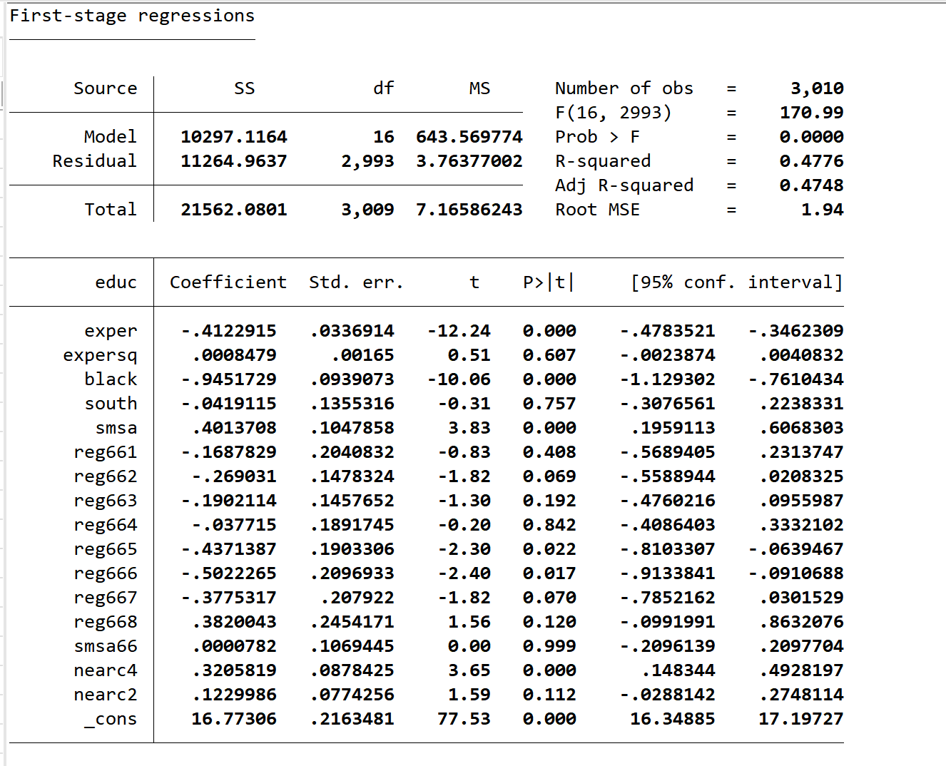

显然是nearc4更为显著，其与educ的相关性更强
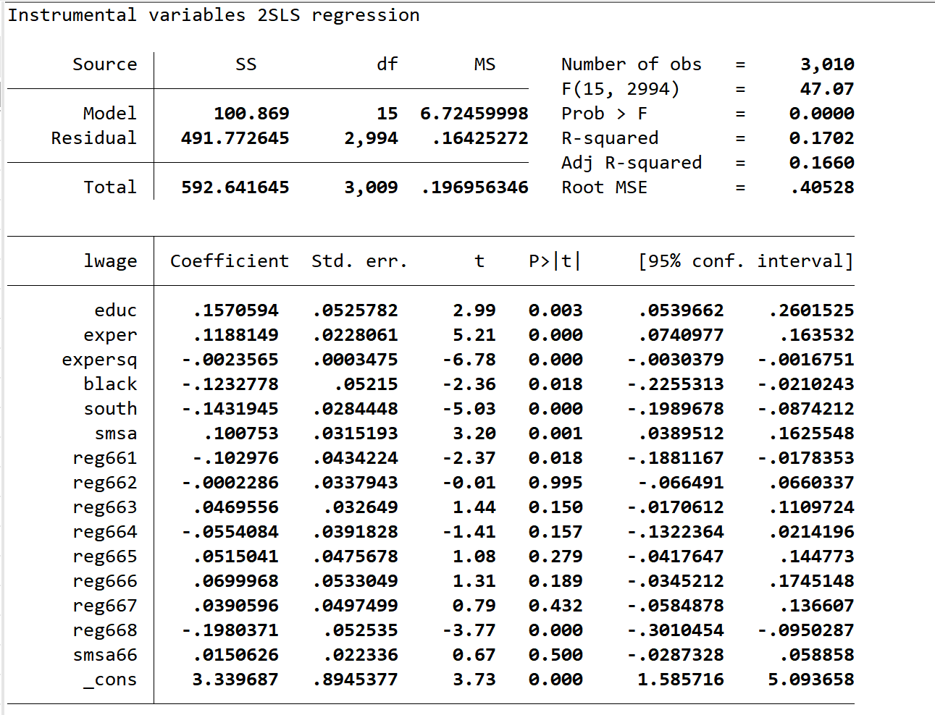

e.
reg iq nearc4
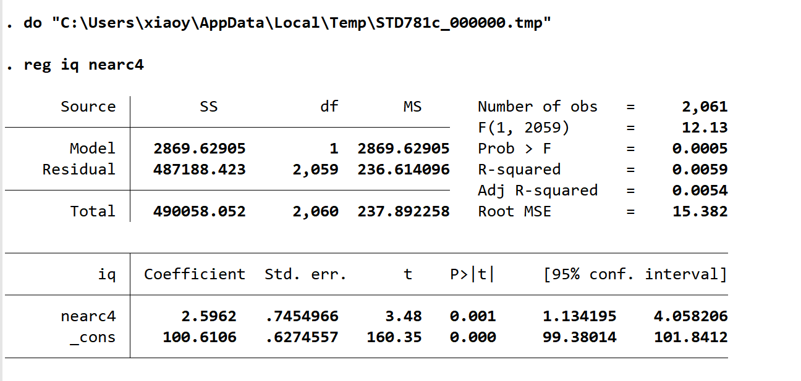
they are correlated
f.
reg iq nearc4 smsa66 reg661 reg662 reg668
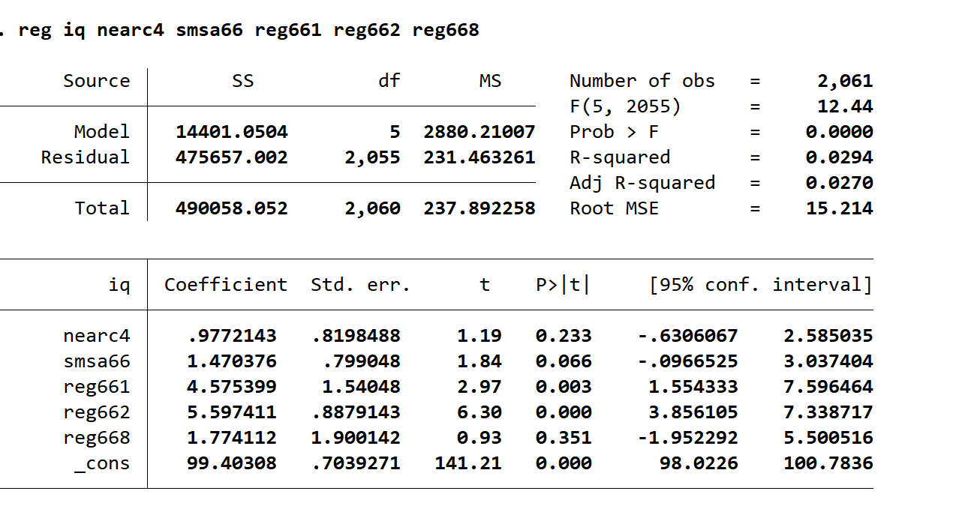
they are nocorrelated
在对数工资方程中控制1966年的地理位置和地区虚拟变量的作用主要是为了反映地理位置对收入的影响，通过引入这些虚拟变量，可以观察不同地区或不同地理位置的工资是否存在差异，可以更准确地估计其他解释变量对工资的影响。

